ADC Characterization / Calibration Notes
Christopher Kalitin

Looks like the offset is my problem:
(From the STM32f031k6 datasheet stm32f031c4.pdf)
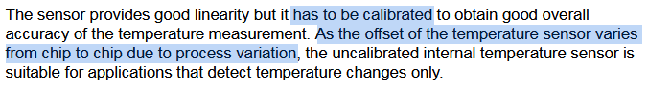

ADCs seem to be accurate to plus minus 3 in the worst case. On the range of 4095, this does not account for the errors I’m seeing, so calibration is necessary.
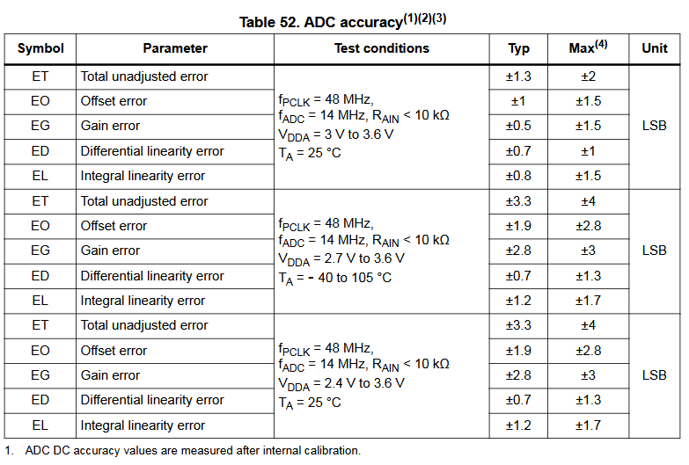

They are all SAR ADCs.

Offset error expressed in LSBs (Least Significant Bit, ie. 1 (2^0)) is what’s needed.

All other error types seem to be very similar to the offset. Some apply differently over the range though. Ie. offset would change the entire graph, while adjusting by the other error types give different results across the entire range. Like our multiplicative offset.

Total Unadjusted Error is not the sum of all other error types. It’s the maximum derivation that can occur between ideal and actual digital values.

